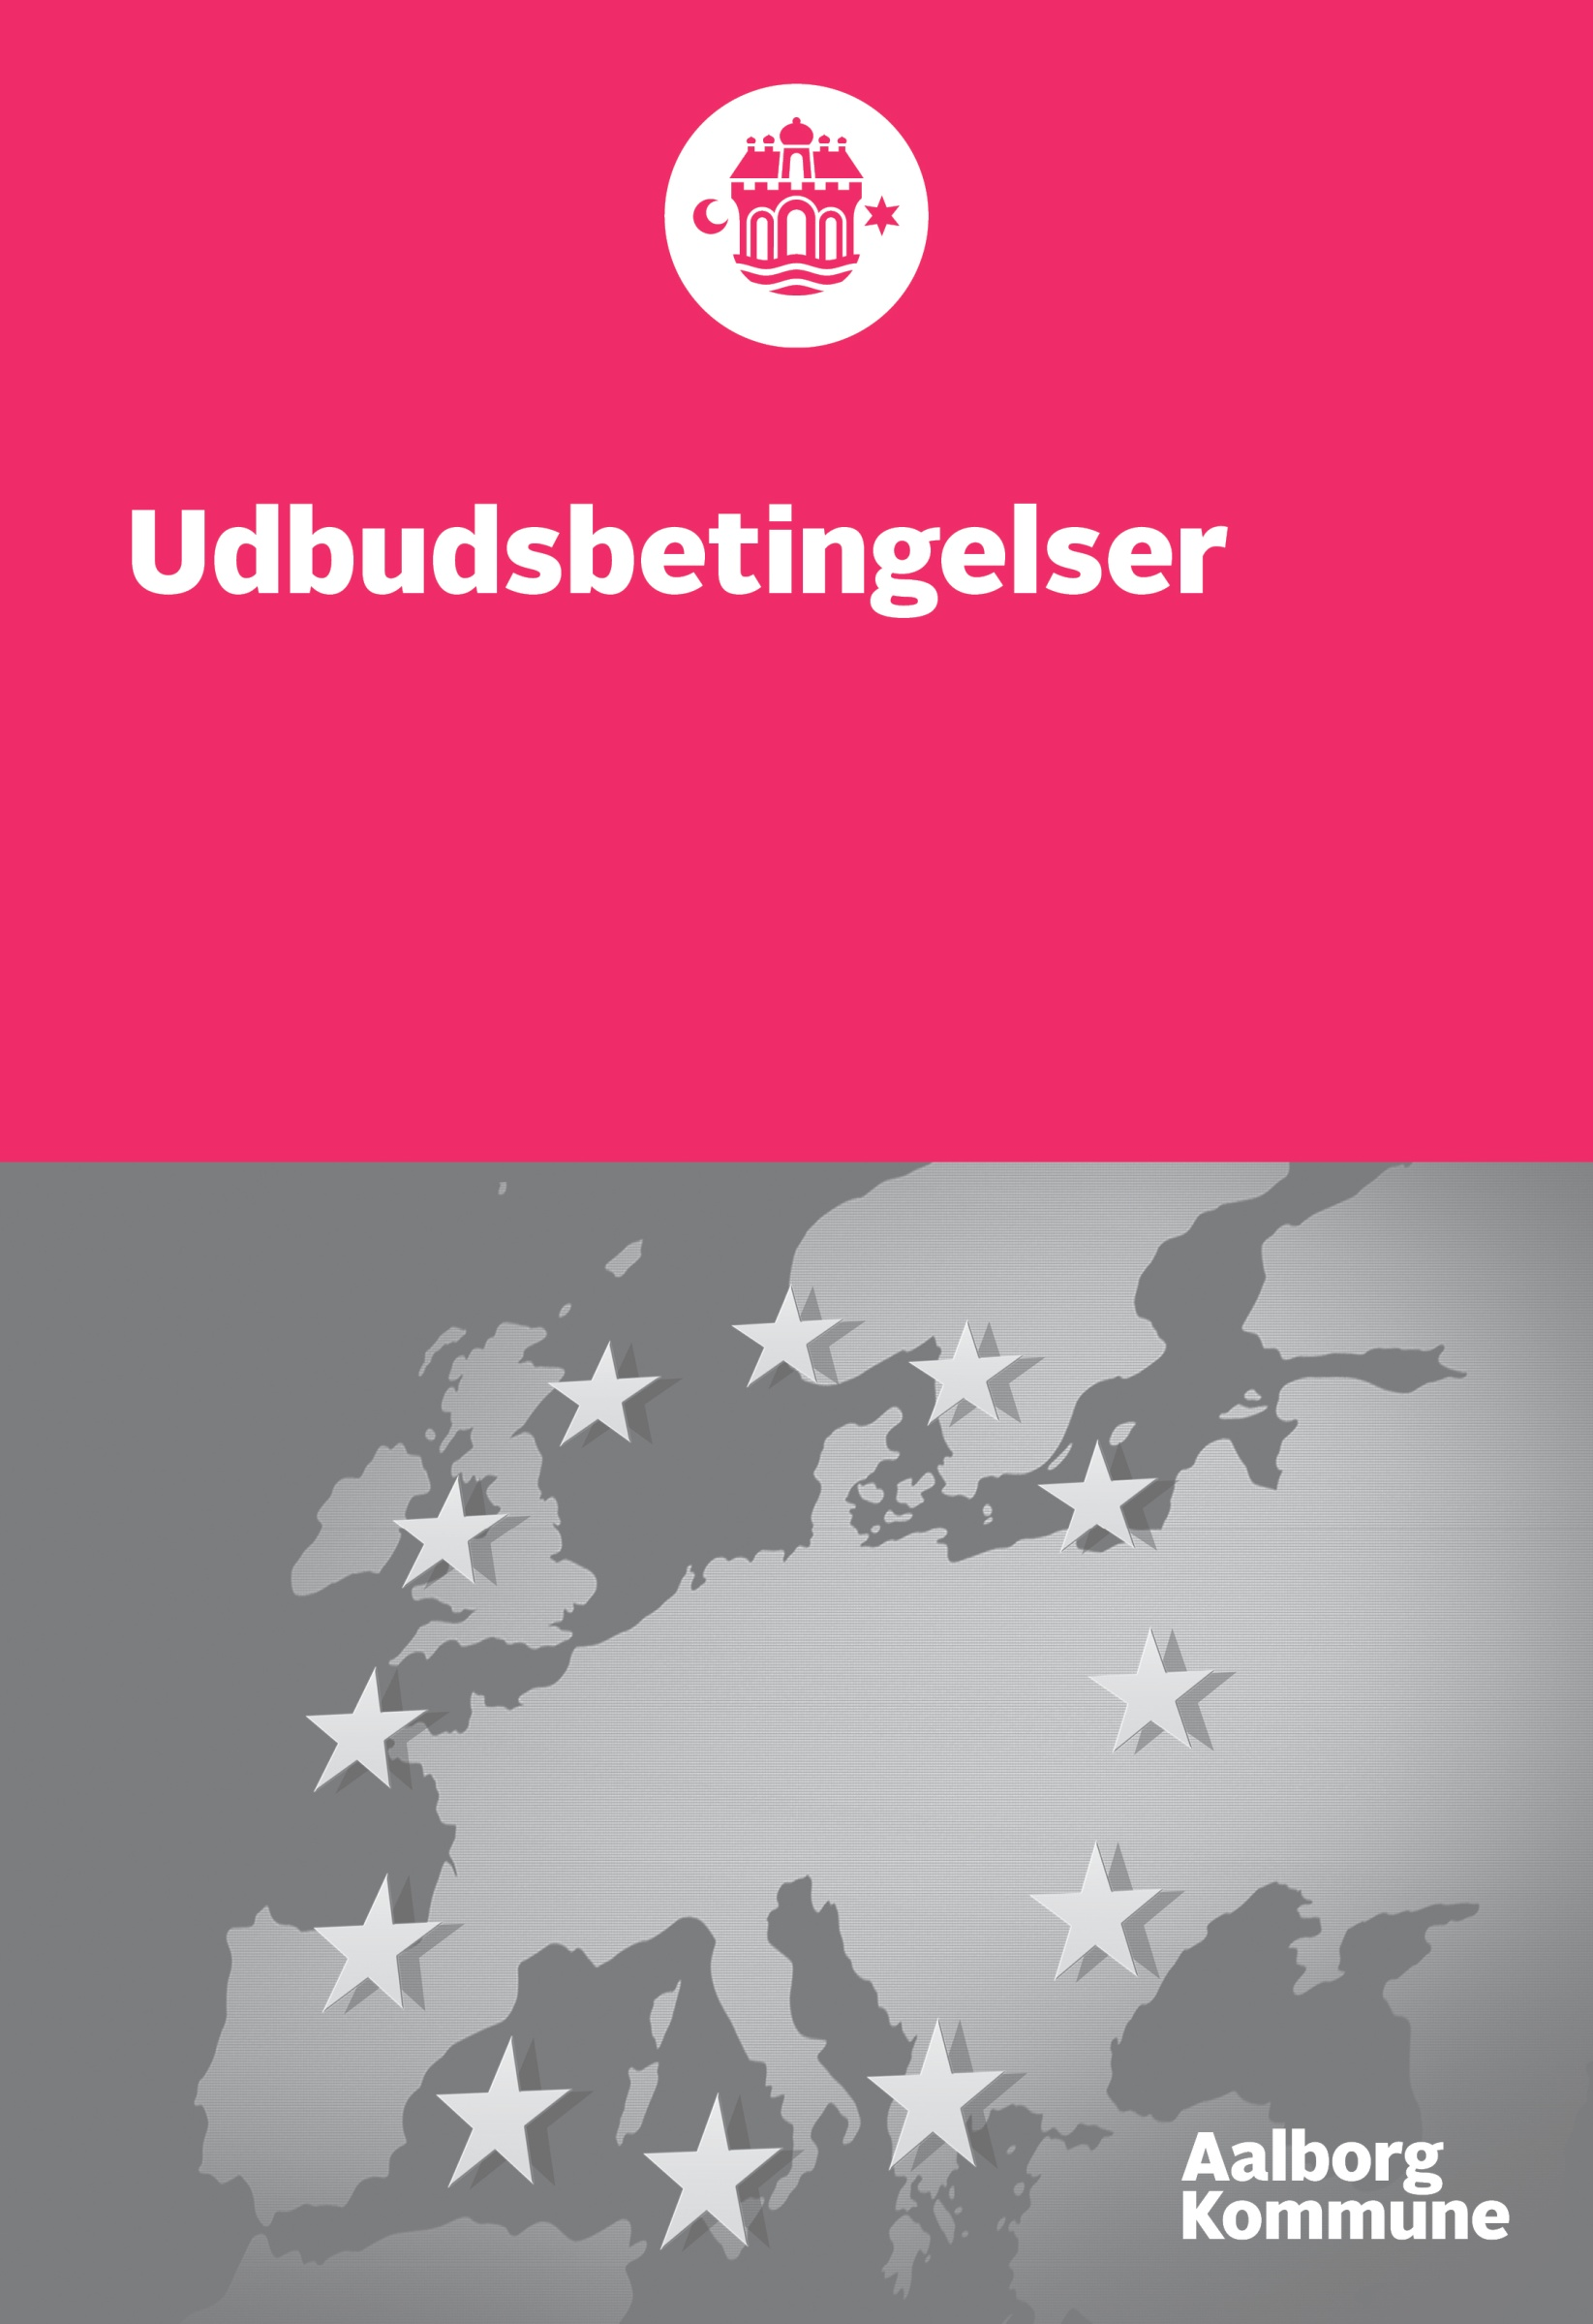

Draft Consultancy Agreement – appendix 3

Consultancy Agreement
This Consultancy Agreement (hereinafter called the ”Agreement”) is entered into by and between
City of Aalborg
Department on Environment- and Energy
Stigsborg Brygge 5
9400 Nørresundby
Denmark

(hereinafter called the “AAL”)

And

*Tenderer
Company no. ‘
Contact person *

(hereinafter called the “Consultant”)

- Definitions

  - As used in the Agreement, the following words have the following meanings when written with a capital first letter:

“Agreement” means this Consultancy Agreement, including Appendices hereto, as may be amended from time to time in accordance with Clause 11.1 hereof.

“Fee” means the fee payable by AAL to the Consultant for the Work performed under Clause 4.1 hereof as included in the Tender List (appendix 2).

“Party” or “Parties” means the Consultant or AAL, individually, or the Consultant and AAL, collectively.

“Requirement Specification” means a description of the Work, including, without limitation, key persons, tasks, deliverables and completion dates, as set out in Appendix 1, 1.1 and 1.2 hereto.

“Work” means the work to be performed by the Consultant for AAL under the Agreement, as set out in the Request for Tender with appendices including the Requirement Specification with the appendices 1.1 and 1.2.

- Scope of Agreement

  - AAL hereby commissions the Consultant to perform the Work, and the Consultant hereby accepts the commission, on and subject to the terms and conditions set out herein, including, without limitation, the Requirement Specification with appendices. The Consultant must perform a task, even if only mentioned in either the Requirement Specification, appendix 1.1 or 1.2. .

  - The Consultant shall perform the Work as an independent contractor and shall not be an employee of AAL for any purpose. The Consultant shall have no authority to enter into any agreement on behalf of, or otherwise to bind, AAL.

  - Other than this Agreement the following appendices shall apply:

- Appendix 1 Requirement Specification with appendices 1.2 and 1.2
- Questions and answers and/or amendments given and/or published by AAL during the tender procedure
- Request for Tender with appendices
- Appendix 2 Tender List
In the event of discrepancies between the Agreement and appendices, the Agreement takes precedence. In the event of discrepancies between the appendices, the appendices shall apply in the above mentioned order.
The Consultants gereral terms and conditions of sale do not apply to service rendered under this Agreement.

- Duties

  - The Consultant shall perform the Work in a professional manner, in compliance with all applicable legislation and in compliance with the tasks described in the Request for Tender with appendices.

  - The working language is English.

  - The Consultant shall inform AAL immediately of any anticipated material deviation from the Statement of Work, stating the cause of such deviation, the effects of the deviation and any possible remedial actions.

  - The Consultant shall inform AAL immediately should the Consultant begin working on other contracts regarding Public Procurement projects, while carrying out the Work.

  - The Consultant shall provide, at its expense, all labour, equipment, tools, materials, travels, accommodation and other things necessary to perform the Work unless otherwise agreed in writing by the Parties.

  - AAL shall provide, at its expense, such access to its personnel and information as is reasonably necessary to enable the Consultant to perform the Work.

  - The Agreement is personal to the Consultant, and the Consultant shall not assign any rights or obligations hereunder or subcontract the Work without the written consent of AAL.

  - Offered people in the External Consultancy Team
The Consultant may replace the offered persons in the External Consultant Team if the background is explained ex. termination of the employment relationship with the Consultant or add new knowledge to the project.
A replacement of the offered persons in the External Consultant Team can be accepted only if the overall level of competence and experience is preserved. The Consultant shall, in respect of AAL, document the reason for the replacement and explain that the replacement does not cause the overall level of competence and experience to be impaired.
If AAL after a period of 60 calendar days, estimates that a replacement of one or more persons in the External Consultant Team has resulted in the advisory team being unable to preform the advisory task at a satisfactory level, the Consultant at the request of AAL must change the composition of the External Consultant Team to ensure that the advisory task is always carried out by a team with the skills and experience offered.
Replacement of key persons must be communicated without undue delay to AAL.

- Fee

  - The Parties have agreed upon the following Fee: * EURO for the fulfilment of the Agreement. The Fee is fixed during the period of the Agreement.

  - The Fee shall be inclusive of any and all expenses, for instance travel costs and accommodation, incurred by the Consultant in performing the Work unless otherwise agreed in writing by the Parties.

  - AAL shall not be required to pay for any work performed by the Consultant that is outside the Work, unless AAL has consented to such work in writing prior to its commencement. The Consultant is obliged to write an offer including a description of the work and fee before AAL can consent to additional work. The information in the Tender List regarding hourly rate per category of employees are binding in respect of the preparation of the written offer. The Consultant is not eligible to charge a fee for the preparation of the written offer. AAL is not obliged to accept the written offer made by the Consultant.

  - The Fee shall be invoiced to AAL on a monthly basis, the first working day of the month. The invoice shall consist of the following amount * EURO (equaling 1/31 of the Fee) and the invoice shall regard the previous month.

The invoice must be sent electronically in accordance with “Lovbekendtgørelse nr. 798 af 28. juni 2007” on public payments etc. as well as “Bekendtgørelse nr. 354 af den 26. marts 2010” jf. “Lovbekendtgørelse” to the following EAN no. 5798003752167 and consist of the following information:

- Att.: Project Circular PP, Birgitte Krebs Schleemann
- Workpacage
- Periode
- Consumed hours
- Travel and accommodation expences, if any during the period

AAL must make payment no later than 30 calendar days after receiving a proper and valid invoice from the Consultant.

- Work product /Third Parts rights

  - The ownership of all work products of any kind produced by the Consultant in performing the Work, including, without limitation, materials, knowhow, trade secrets, inventions, designs, copyrights, trademarks and other intellectual property rights, shall pass to AAL without any fee.

  - In fulfilment of Clause 5.1 hereof, the Consultant shall, upon the AAL’s request, deliver to AAL all work products in its possession or control and perform all such acts and do all such things as are reasonably necessary to perfect AAL’s ownership of the work product, at the AAL’s expense.

- Confidentiality

  - The Consultant shall keep all information obtained from AAL or other partners in the Circular PP project in connection with the performance of the Work strictly confidential and shall not disclose it to any third party or use it for any purpose other than the performance of the Work without the AAL’s prior written consent.

  - The restrictions set out in Clause 6.1 hereof shall not apply to any information generally available to the public, obtained by the Consultant in good faith from a third party, independently developed by the Consultant without use of the AAL’s information or required to be disclosed by law.

- Limitation of liability

  - In no event shall either Party be liable to the other Party for any special, indirect, consequential, exemplary or incidental loss or damage, however caused, arising out of or relating to the Agreement.

- Term

  - Description of the contract period (1 March 2018 – 30 September 2020)

  - The Agreement shall commence when signed by both Parties and shall terminate upon completion of the Work, unless terminated earlier as provided in Clause 8.3 or 8.4 hereof.

  - AAL may terminate the Agreement at any time for any reason subject to 15 working days’ written notice of termination to the Consultant. AAL shall pay the Consultant for any Work performed up to the effective date of termination if such Work was performed in accordance with the Agreement. The Consultant is not entitled to payments regarding the remaining period of the Agreement.

  - Either Party may terminate the Agreement by written notice of termination to the other Party, effective immediately, if the other Party fails to remedy any material breach of the Agreement within 5 working days of receiving written notice of such breach.

- Liability and insurance

  - Each party is liable under Danish law, general rules for failure to participate in the proper fulfillment of the agreement.
An agreed bid does not prevent the Contractor from claiming compensation for any further loss. However, this does not apply if the function of the booth is to replace for the liability.
The Consultant is during the entire period of the Consultancy agreement bound to maintain a valid advisory liability insurance. At the request of AAL, the Consultant shall prove the existence and extent of the insurance. Failure to submit documentation within a reasonable time is considered to be essential lacking maintenance.
- Ethics and social responsibility
AAL assumes that the Consultancy Agreement and its subcontractors comply with international conventions acceded by Denmark, including the following basic ILO conventions:
  - Forced labor (ILO Conventions No. 29 and 105)
  - Labor clauses (ILO Convention No. 94)
  - No discrimination in employment (ILO Conventions No. 100 and 111)
  - Minimum age for access to employment as well as prohibition and immediate action to abolish the worst forms of child labor (ILO Conventions 138 and 182)
  - Safe and healthy working environment (ILO Convention No. 155) as well Organizational freedom and right to collective bargaining (ILO Conventions 87, 98 and 135), within the framework of applicable legislation.
It is further assumed that the Agreement and its subcontractors respect fundamental human rights, including compliance with the UN Human Rights Declaration and the European Convention on Human Rights, and comply with the 10 principles of the UN Global Compact.

- Miscellaneous

  - The Agreement contains the entire understanding of the Parties with respect to the Work. The Agreement may not be amended except by written agreement signed by both Parties.

  - The Parties are liable for “defects” and delays under this Agreement in accordance with Danish law. The Consultant is not obliged to stop working under the Agreement for any reason, other than having terminated the Agreement.
  - Any disputes arising out of or in connection with the Agreement which cannot be settled amicably by the Parties shall be resolved by a court of competent jurisdiction in Denmark, city of Aalborg, in accordance with the laws of Denmark excluding conflict of law principles.

  - The provisions of Clauses 2.2, 5.1, 5.2, 6.1, 6.2, 7.1, 8.3, 8.4 and 11.3 shall survive termination of the Agreement for any reason.

For and on behalf of For and on behalf of
Consultant AAL

Name: Name
Title: Title:
Date: Date:

