PRESS RELEASE

Amada Norway A/S

Amada opens new Technical Center for Northern Europe

Amada has launched a new 9,500 m² Technical Center facility in the United Kingdom to serve as a base for customer support not only in the UK but also in Spain and Scandinavia. The new Technical Center is fully equipped with a machine showroom, rooms for proposal and presentation to customers and a school for technical training. Further facilities include a tooling factory, a 60 seat seminar theatre and an automated spare parts warehouse.

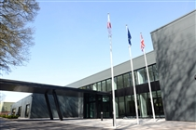

Picture 1. Entrance to the UKTC

With over 800 visitors in the first month, the new center showcases the ultimate in new technology for sheet metal processing. Seven new machines are being shown for the first time in the UK, with the focus on the European Launch of the new LCG-3015AJ 2kW fiber laser and LCG-3015 3.5kW CO2 laser. The new LCG Laser cutting machines provide users with advantages such as higher speed cutting and ECO manufacturing. Additional new technology includes the EG-AR automated press brake, FLW fiber laser welder, HFE3i and HG press brakes and EM-3612M II turret punch press.

Amada UK was first established 42 years ago and the original UK Machine Tool Plaza first opened in 1986 with just 42 staff. The organisation has now grown to over 160 employees and the Plaza has been updated to a Technical Centre to meet the needs of customers who visit daily.

This investment by AMADA demonstrates a further commitment to the Northern European market. Recent improvements include establishing a new European Headquarters, new companies to promote direct sales and support throughout Eastern and Northern Europe and a new Technical Center and Research and Development Center in Southern Germany (Amada Advanced Technology GmbH). By setting up this new UK hub the aim is to strengthen the engineering and service support offered by Amada throughout Scandinavia as well as expanding the range of machines available for customer verification.

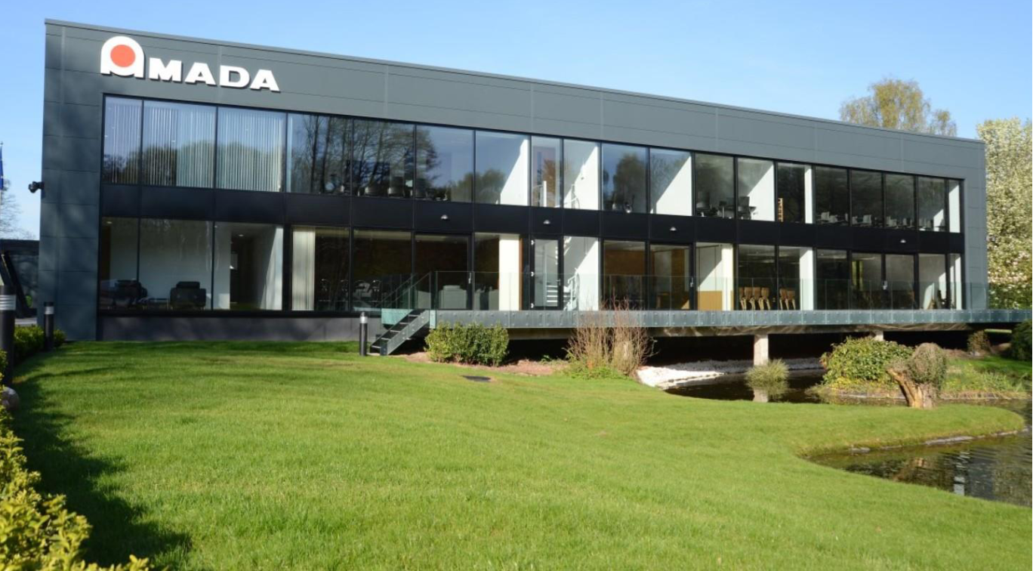

Picture 2. View from the garden towards the UKTC

As a part of the expansion, Amada is also reinforcing its presence in Norway by adding resources and developing the organisation. The starting point is to build a strong service and engineering team based on the extensive knowledge and long experience of the existing staff.

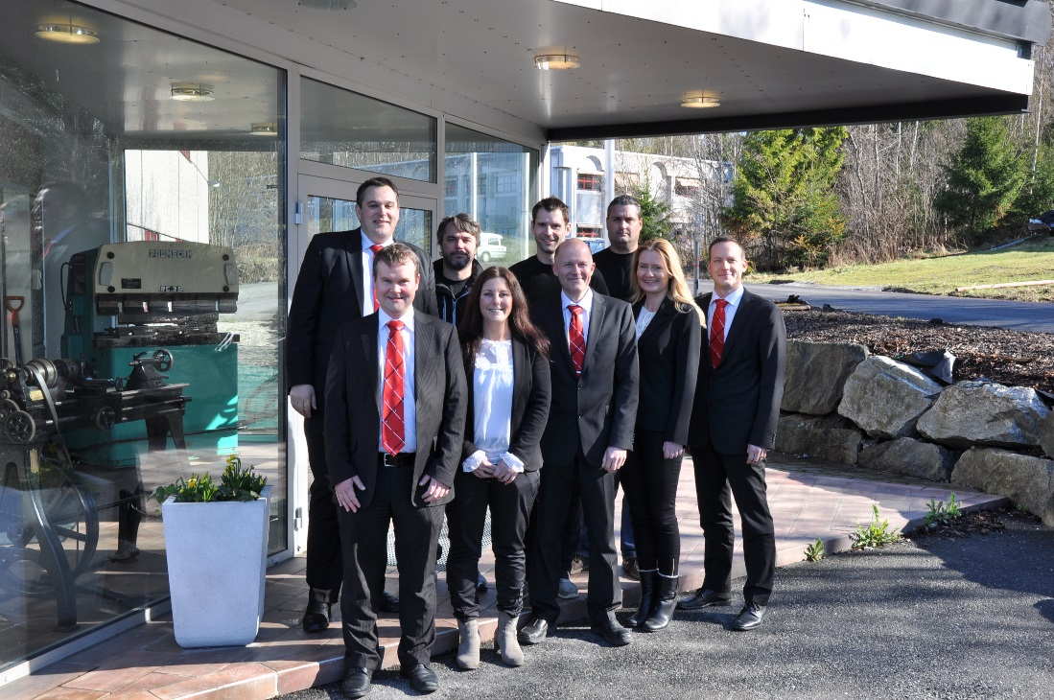

Picture 3. Amada Norway Team. (3 persons missing from the photo)

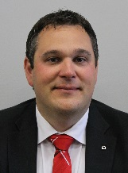From January 1st, 2014 Peter Book is assigned as Senior Sales Engineer. Peter has worked within Engineering and Sales in Amada for around 20 years.

Picture 4. Peter Book

Dan Liljeqvist was appointed as General Manager for Amada Norway. Dan has worked with Amada the last 15 years and previously as a General Manager at LKI Käldman Ltd., providing Automation solutions in Europe and North America.



Picture 5. Dan Liljeqvist

With this support from Amada UK, the organisation is being developed to meet the market’s demand and raise brand awareness in Norway. “We have a strong team and with the added product and production process knowledge of Peter Book and the support of Amada UK, we can offer our customers a more comprehensive solution. We see great possibilities to expand our business in Norway” added Dan Liljeqvist.

For further information please contact:

Anita Volden

+47 64 97 31 01, anita.volden@amada.no, [www.amada.no](http://www.amada.no) / [www.amada.co.uk](http://www.amada.co.uk)



**Amada Norway AS Myrveien 12 N-1430 Ås. Telefon: +47 64 97 31 00**

**NO 933 966 674**