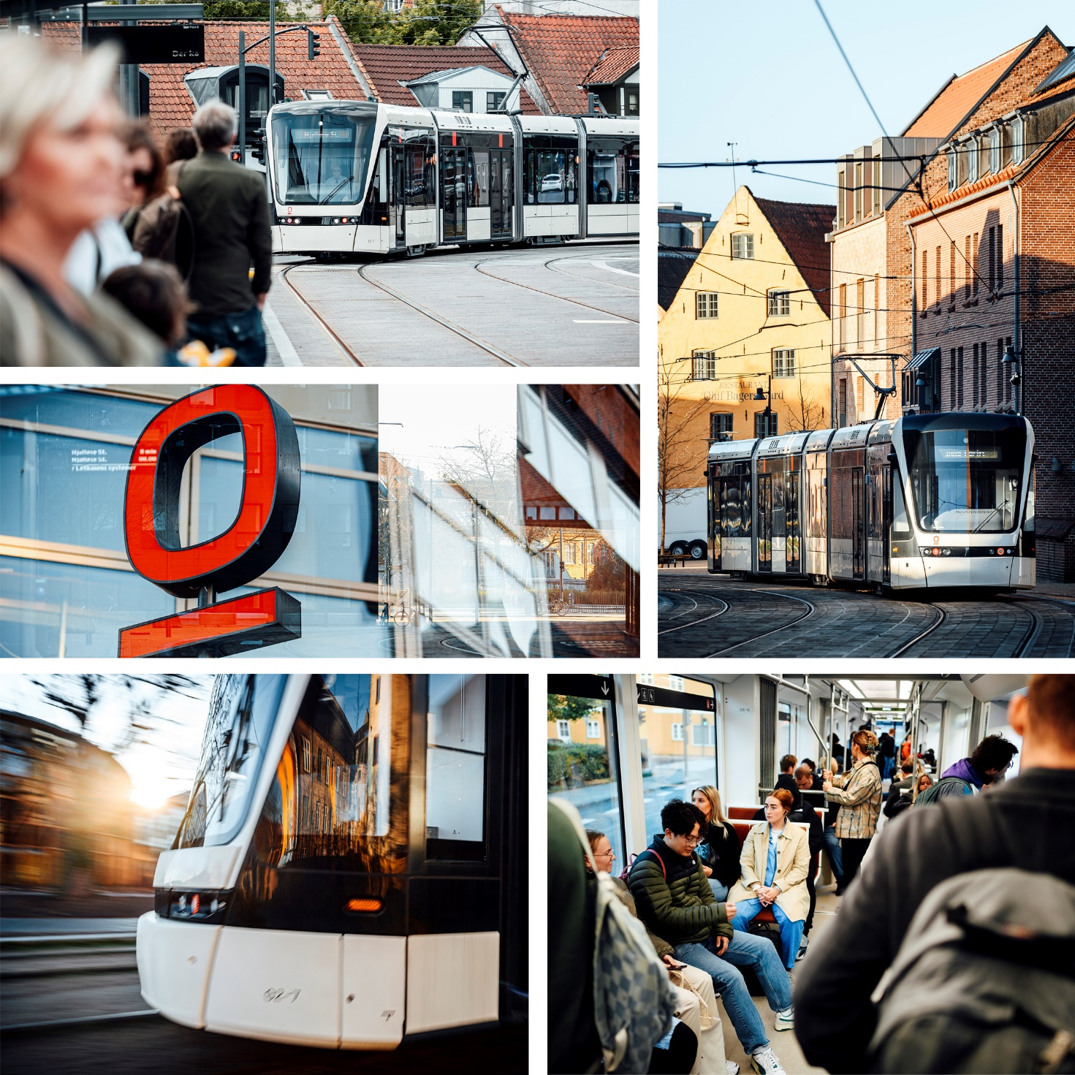

Overhead Wire De-Icing
Contract
Content

Condition of Contract 4
Authority Approvals 5
Contractors’ obligation 5
Clients’ obligation 5
Liability 6
Payment and price 6
Clauses 7

ODENSE LETBANE
Overhead Wire De-Icing
Contract Agreement
OT-CT-OPM-CT-0008
Odense Letbane P/S
Søndre Hospitalsvej 10
5260 Odense S
Denmark
Company no. 36 47 84 97
(Hereinafter called the “Client”)
And
xxxxxxxxx
xxxxxxxxxxxxxxxxxxxxxx
xxxxxxxxxxxxxxxxxxxxxx
xxxxxxxxx
Company no. xxxxxxxxx
(Hereinafter called the “Contractor”)

Condition of Contract

Introduction.
The purpose of the Contract is prevention of ice and frost on the overhead tram wires in the winter period October 2023- March 2024.
Odense Letbane P/S was commissioned in May 2022. The Railway consist of 2 x 14.2 km contact wire and a depot arear with contact wire. These overhead contact wire supply 750V direct voltage to the Light Rail section from Tarup Center in the north to Hjallese Station in the south.
Ice on the contact wire/overhead line can cause light rails to lose power, generate damaging arcs, disturbing the modern engine control and destroying both the pantograph and the overhead wire. The ice will in any case cause arcing and lead to excessive wear to the pantograph conductors, and in worst case cause traffic delays and service disruption.
Odense Letbane needs to make sure that there does not occur disruption due to ice on the contact wires.
As part of the prevention of icy overhead lines during the winter period, Odense Letbane thus wants treatment with a form of spraying/coating of the overhead contact wire system with Interflon Iceguard, or the Nordic Version of IceGuard with similar or better properties in preventing ice and frost formation on overhead wire.
This agreement is valid for the entire winter season 2023/2024.
The Parties:
On behalf of Odense Letbane P/S,
- Project manager Jan Steinhaugen, janst@odenseletbane.dk, +45 30710217
On behalf of XXXXXXXXXXXXX
- XXXXXXXXXXXXXXXX,
The contractual consists of
- Condition of Contract,
- CSR
- Announcement on www.udbud.dk
- Tender offer, ref. XXXXXX
In the event of a conflict between these documents, a higher-ranking document takes precedence over a lower ranking document.
Contract sum
The contract sum for the contractual performance of the assignment is:
EUR xxxxxx
Cf. the offer “shared transport with Aarhus Letbane” reference no. SP049516

Authority Approvals
The Contractor shall at its own expense arrange for all necessary authority approvals, licenses and permits necessary for use of IceGuard IR or Nordic version of IceGuard IR. The Contractor requires a SDS document (cf. EF nr. 1907/2006) and a Technical Data Sheet for each product used under this Contract.
The environmental authorities must have access to the Contractor's data sheet on the liquids (both IceGuard and the Nordic version of IceGuard) this contract is entered with the clear caveat and prerequisite that the environmental authority can approve/accept the use of the IceGuard on the Client's overhead wires. If the authorities have any objection to use of the products, this Contract goes in “Stand Still Period”, until the authorities indicate that the product is safe to use, or the authorities have no disapproval to use of the product. If the environmental authorities find that the Products is not compatible for the purpose, due to the environment, the Contract is void without any cost for either Party. The Contractor may not request any exemption from any regulations in force without the Client’s prior approval.
If the product in any way causes any damage, including environmental pollution, the Contractor must indemnify the Client. Unless the Interflon Iceguard data sheet includes information, regarding restrictions for use of the product out in the open and the Client has breached its obligations

Contractors’ obligation
The Contractor offers service to prevent the formation of frost on the Overhead wire. The Contractor will perform a minimum of 6 shifts for the Contract period. A shit includes 1 night of sprayings for all of the Overhead Wire to the tram, including the wire on the CMC area. The CMC must be sprayed on the daytime, however the overhead wire from Hjallese to Tarup can only be sprayed in the nighttime from 02:15 to 04:15, as the work otherwise will require an interruption of operations, which under any circumstances cannot be accepted. The Contractor must therefore demonstrate flexibility within reasonable limits, in order to avoid any kind of operational disruption.
The Client will work out a timeline for the Contractor for each shift.
The Contractor will provide the necessary operator for the Interflon equipment, used to spray the overhead wires. The Contractor will at its on-cost transport the equipment to Odense and back.
The Contractor will deliver all the necessary fluids per shift. The quantity is based on the contractor's professional assessment on how much fluid is necessary to make sure that all the overhead wires is proper covered.
All liquids used for the performance must be delivered shortly before the time of the performance.
The Contractor shall affect complete performance in time, in the quality necessary to achieve the purpose of the Contract, and complying with the relevant professional diligence, as well as the state of technology.

Clients’ obligation
The Client is responsible for the organization of the safety workplan and the provisions necessary to ensure safety for the workers.
To perform the spraying on the overhead wire, the Client will provide a Uromac or applicable service vehicle and lorry on which to install the automated spraying unit. All cost for use of the Uromac, such as Diesel and driver is solely the Clients responsibility. It is the Clients infrastructure manager Keolis Odense Letbane, who will be responsible for the delivery of these, by specific agreement, between Keolis and the Client.

Liability
Either Party shall be liable for any deliberate or negligent action or omission of their staff or subcontractors in accordance with statutory law.
All services must be delivered without any kind of delays. If either of the Party cause any kind of delay, it may cause the other Party further expenses, thus it is very important that all kind of delays is avoided. Any anticipated and known delays must be notified immediately to the other Party. The notification shall contain all the information relating to the significance of the delay in relation to the performance of the contract.
If either Party performance of its obligations under this Agreement is prevented or delayed by any act or omission of the other Party or its agents, subcontractors, consultants or employees, the afflicted party shall not be deemed in breach of its obligations under this Agreement but the causing Party will be liable for any costs due to the prevention or delay, in each case, to the extent arising directly or indirectly from such prevention or delay.
In a case of force majeure from any Party, then as well as other legal competencies the Parties has authority to dissolve or suspend the agreement with the other party, in the latter case for the duration of the status of force majeure. When availing itself of this authority, Either Party shall not be committed to compensation.
By the notion of force majeure shall be understood unforeseen circumstances, for instance relating to persons or objects that either Party uses in carrying out the agreement and which by their nature render execution of the agreement impossible or so troublesome and/or costly that fulfilment of the agreement cannot in reason be demanded by the other party. Among such circumstances are production or unusual traffic disturbances, extreme weather, fire damage, floods, strikes, government measures, the failure of the other party or of third parties enlisted by either Party in the execution of the agreement.

Payment and price
Any kind of changes to the price, must at all-time be approved. The invoice must comply with the Clients payments sheets.
All invoices must be sent free of charge, cf. LBK No. 798 of June 28, 2007 on public payments, etc. The supplier must submit invoices with reference to the contractor EAN number, cf. below.
The contracting entity prefers electronic invoices formed in the supplier's own economic and invoice system. Information on e-invoicing can be found at www.oes.dk.
Invoices must contain the following information:
• EAN no.: 5798006615070 IBAN:
• DK1820004388134955
• BIC/SWIFT: NDEADKKK
• Product Description and Initials for the Client's contact person
• Invoice amount
• Contract holder's VAT number.
Electronic invoices must be prepared in the common public format OIOUBL.
The contracting entity is entitled to postpone the payment until the correct invoice is available if the invoice does not meet the above requirements.

Clauses
The ten basic principles of social responsibility in the UN Global Compact will be required to be observed. In addition, contractual requirements are imposed in accordance with ILO Convention No. 94 on Clauses in Public Contracts and Circular No. 9471 of 30 June 2014.
Social and labour clause
It is important for the Client that the supplier focuses on promoting a good physical and mental work environment, preventing wear and tear and maintaining and developing the workforce. It is also important for Odense Letbane that the supplier focuses on "the inclusive labor market". See the requirements
Provisions on social clauses, ethical and social responsibility as well as work clauses must be complied with
The Client wishes for all its contractors to ensure that the workers’ rights in connection with work being carried out for the Client is comprehend to Odense Municipality standard terms. Contractor shall therefore comply with Labour Clause: www.odense.dk/erhverv/udbud/kontrolenheden/labour-clause.
The Contractor shall comply in all respects with Odense Municipality's Labour Clause concerning assurance of workers’ rights, including the provisions about documentation, penalties, termination, and inspection visits.
Odense Municipality's environmental policy "Sustainable together" - is Odense Municipality's environmental policy. For further information on this, see https://www.odense.dk. The environmental policy sets the political framework and direction and invites to create sustainable and innovative solutions to joint efforts between the municipality, citizens, volunteers, associations, organizations, and business.
A key element of "sustainable together" is that it must be done through collaboration, networking and dialogue. It is important for the Contractor that all partners respect Odense Municipality's environmental policy.

