TENDER CONDITIONS

for

Delivery

Of

IR Blackbody

Tender DOCUMENTS
The complete tender documents consist of:

- Notice on www.udbud.dk
- These tender conditions
- DALO's Terms and Conditions
- DALO's Requirement Specification
- Cover Letter (template)

THE delivery
The full and detailed description of the delivery is contained in DALO's Requirement Specification and the notice on www.udbud.dk.

Technical specifications and standards
The tender documents may contain requirements that are expressed in the form of technical specifications, such as an ISO standard or a reference to a Nato Stock No. / part number. This shall only be understood as a reference to the quality required. Thus, if any technical specifications do not include the words "or equivalent", the text should be understood to include the words "or equivalent". Similar products, able to fulfill the same requirements / needs and of an equivalent quality, can therefore also be offered.

award criteria
The Contract will be awarded on the basis of the award criterion "the economically most advantageous tender". In the evaluation of the tenders the Contracting Authority will use the following criteria with the specified weighting.

Should the situation arise, that two tenders achieve the exact same evaluation, and are these two tenders the economically most advantageous tenders, DALO will award the contract after drawing lots under strict observation of the principle of equal treatment.

1. Price 40 %

With regard to the financial sub-criterion ”Price,” each tender will be awarded points in accordance with a financial framework.
The financial framework is lowest price + 50%.
The compliant tender with the lowest price is awarded 5 points.
Tenders with an evaluation-technical price that exactly matches the financial framework (lowest price + 50 %) or exceeds this framework are 1 point.
Tenders with a price that lies within the financial framework are awarded points by linear interpolation:
$$Points by linear interpolation=$$
$$Maximum points-\left(\frac{\left(maximum points-minimum points\right)}{gradient}\right)*\frac{(price of tender-lowest price)}{lowest price}$$
In the formula, price of tender constitutes the price of the tender in question which, using the formula, is awarded points by linear interpolation; lowest price is the price of the compliant tender offering the lowest price; and the gradient is the addition to the lowest price on which the financial framework is based.
The graph below illustrates the contracting entity's award of points in accordance with the financial framework scoring model.

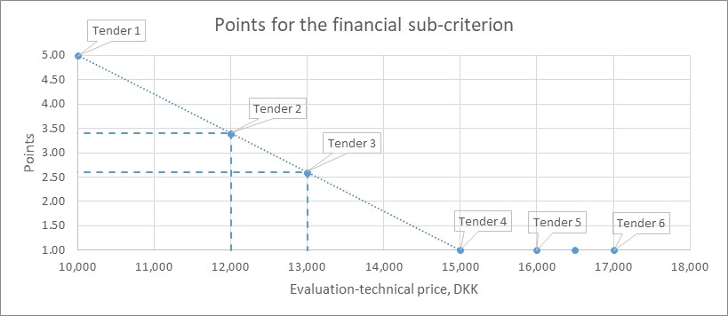
In the example, the financial framework is DKK 15,000 (lowest price + 50 % = DKK 10,000 + DKK 5,000).

2. Quality 60 %

With regard to the qualitative sub-criterion “Quality”, each tender will be awarded points based on the fulfilment of the 9 evaluation requirements in the Requirement Specification:

- Requirement no. 2
- Requirement no. 8
- Requirement no. 10
- Requirement no. 12
- Requirement no. 14
- Requirement no. 16
- Requirement no. 18
- Requirement no. 20
- Requirement no. 22

For each evaluation requirement, the tenderer shall state the requested information in the column “Tenderer’s description” in the Requirement Specification. The tenderer will be awarded points in accordance with the tables in the column “DALO remarks and evaluation”.

Example:

Requirement no. 2 in the Requirement Specification regards the size of the heated surface of the Systems. As described in the column “DALO remarks and evaluation”, the fulfilment of Requirement no. 2 will be graded as follows:

Size | Points
255 x 255 mm or more | 1
270 x 270 mm or more | 2
280 x 280 mm or more | 3
290 x 290 mm or more | 4
300 x 300 mm or more | 5

A tenderer has offered a size of the heated surface of 283 x 283 mm. The tenderer will receive 3 points for the fulfilment of Requirement no. 2.

The overall score for the sub-criterion “Quality” will be calculated as the sum of the points awarded for each evaluation requirement:

$$Points for "\text{Quality"}=\frac{Sum of points for evaluation requirements}{9}$$

3. Overall evaluation

The overall score is calculated as the sum of the weighted score for the sub-criterion “Price” and the weighted score for the sub-criterion “Quality”.

$$Overall score=\left(Points for "Price"*40 \%\right)+(Points for "Quality"*60\%)$$

DALO will not accept a delivery time of more than 240 calendar days, in which case the tender will be deemed non-compliant and not be taken into consideration.

The overall score received by the winning tenderer will be published after award.

reservations
Reservations regarding DALO's Terms and Conditions and the Requirement Specification will not be accepted. If a tender contains such reservations it will be considered non-compliant and not be taken into consideration.

Questions in writing
Questions regarding the tender documents shall be submitted to FMI-KTP-ID-TENDER-LU@mil.dk.

Questions and answers (anonymized) will be uploaded to www.udbud.dk with the other tender documents.

Questions received within the deadline stated below under section 10 will be answered.

Questions received later than that, will not be answered.

The content of the tender
Tenders shall be in English or Danish.

The tender shall contain the following:

- Cover letter – preferably using the DALO template
- Filled out Requirement Specification

Tenderers are especially made aware of that they shall not submit their own terms of delivery or any other documentation not requested by DALO.

Deadline for submitting bids; Timeframe during which the tenderer must maintain the tender
The tender must be submitted by e-mail to FMI-KTP-SC-TENDER-LU@MIL.DK no later than 25 June 2020 at 13:00 CET. Tenders received after this time will not be taken into consideration.

The tenderer must maintain the bid for a period of 3 months after the deadline.

Handling of tenders and complaint instructions
DALO does not consider the tender procedure concluded until the contract is signed and reserves the right to terminate the procedure without an award. Regardless of whether the contract is awarded or not, all tenderers are bound by the terms of the bid until DALO has entered into a contract or the period set out in clause 8 of these Instructions to tenderers has expired.

Should the contract be awarded to a joint group of economic operators (a consortium) the participants of such consortium shall assume joint and several liabilities and appoint a representative of the group who is authorized to be DALO's contact to the consortium.

Complaints regarding the award of the contract must be filed to the Complaints Board for Public Procurement with copy to DALO within 45 calendar days after receipt of the notification letter. The Complaints Board for Public Procurement can however only handle cases in which the contract has cross-border interest or exceeds the thresholds of the Danish Act no. 1564/2015 on Public Procurement (in Danish: “Udbudsloven”) or Directive 2009/81/EC of the European Parliament and of the Council of 13 July 2009.

schedule for the tender procedure
Date, time | Event
11 June 2020 | Submission of the tender notice at www.udbud.dk.
17 June 2020 | Deadline for the submission of questions regarding the tender documents expires.
22 June 2020 | Deadline for DALO's reply to questions regarding the tender document expires.
25 June 2020 at 13.00 | Tender deadline.

