Test of solar panels
Task reference: T201294
Solarventi
Hans Jørgen Christensen
Fabriksvej 8
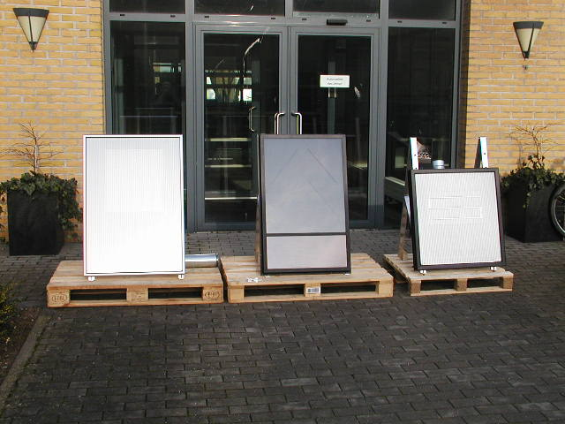
8881 Thorsø

Subject
Following samples have been subjected
to testing to find differences of efficiency
of the solar collectors.

Samples
Solar collector 1 Solarventi
Solar collector 2 Dansolar
Solar collector 3 Scanheat

Applied method
Each solar collector was exposed to sunlight with a intensity of 550 W/m².
The test time (5 min.) started when the air temperature at the air outtake was constant.
Following parameters were measured:
Air outtake volume.
Temperature at the ventilator.
Temperature behind the solar collector.
Noise level 10cm above air outtake .

Results

Temperature sensor 1 is Solarventi.
Temperature sensor 2 is Dansolar.
Temperature sensor 3 is Scanheat.
Temperature sensor 4 is the ambient air.

Measurement 4
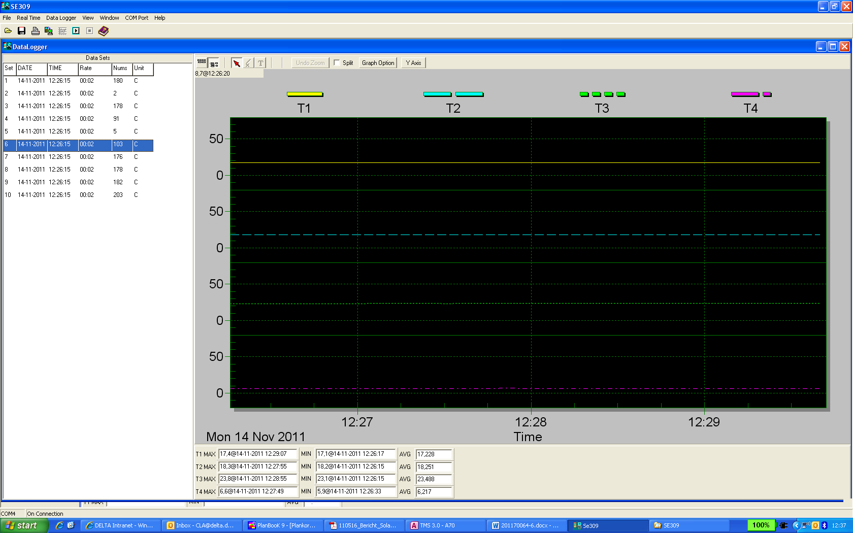

Measurement 5
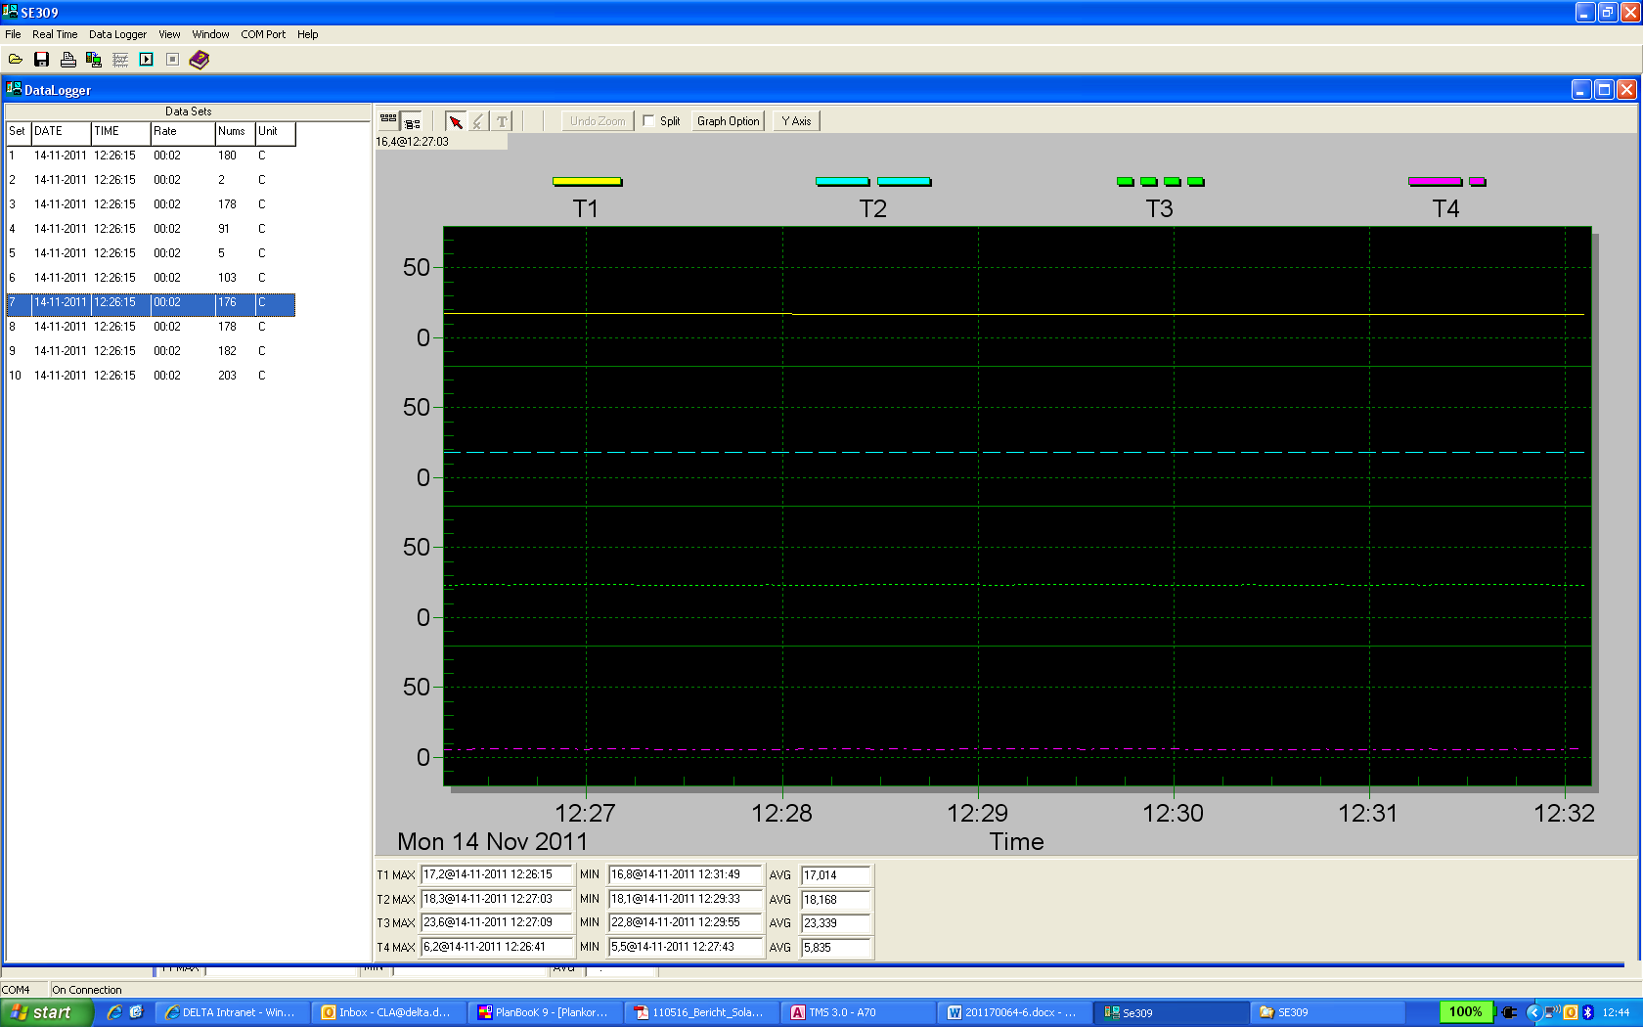

Measurement 6
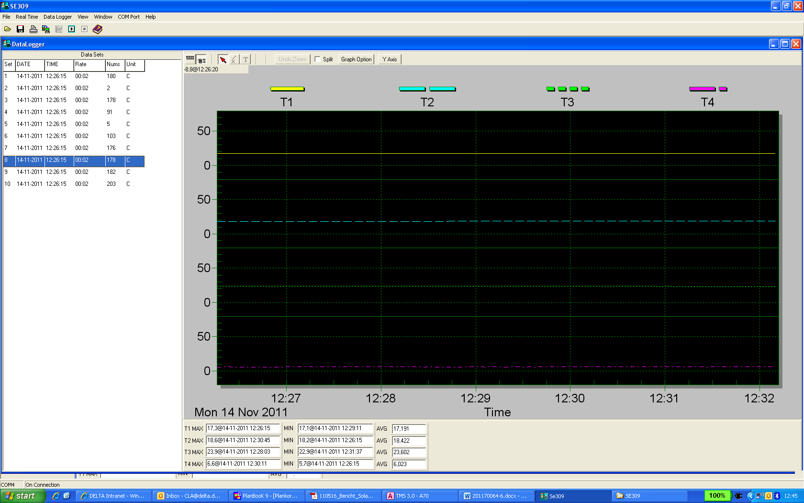

Measurement 7
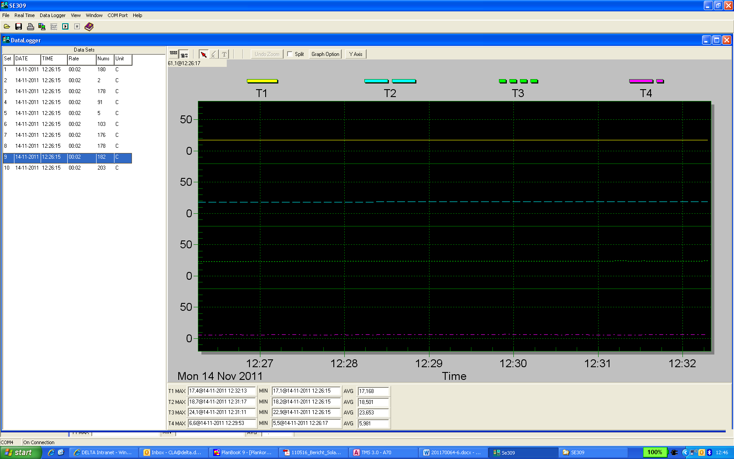

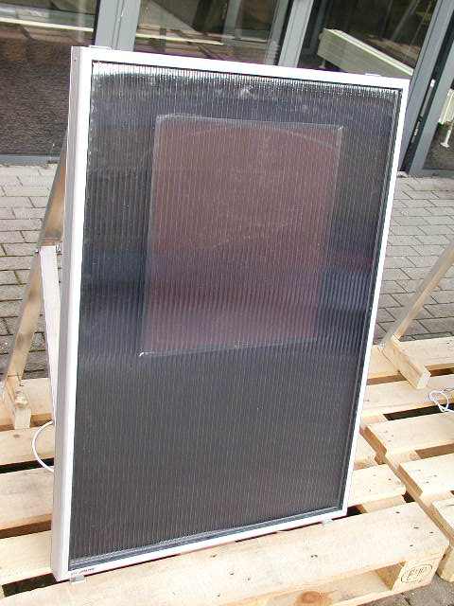
Solarventi
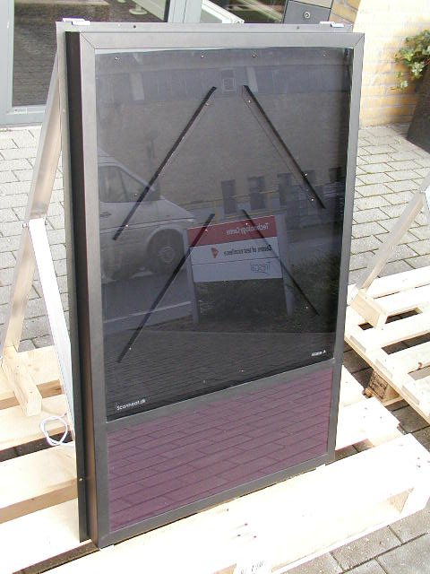
Scanheat

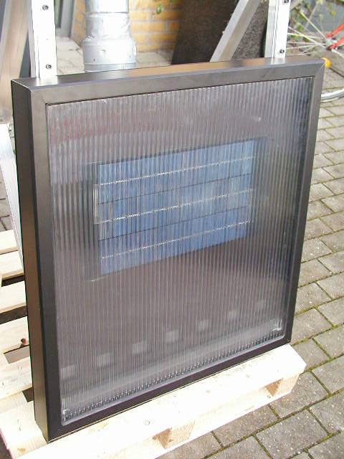
Dansolar

