JUMO safetyM TA: Flexible Safety Limiter
for Demanding Industrial Applications
Press release
PI 2533

Page 1 of 2

Editorial information:
Michael Klose, Press Office
Phone: +49 661 6003-2346
Fax: +49 661 6003-882346
Email: michael.klose@jumo.net

Technical information:
Bodo Schmitt, Product Manager
Phone: +49 661 6003-369
Email: bodo.schmitt@jumo.net

JUMO GmbH & Co. KG

Moritz-Juchheim-Straße 1
36039 Fulda, Germany

Phone: +49 661 6003-0
Fax: +49 661 6003-500

Email: mail@jumo.net
Internet: www.jumo.net

Maximum safety and availability / Simple and
reliable integration into existing systems

The multifunctional safety limiter JUMO safetyM TA sets new standards in process reliability and plant availability. Its certified safety in accordance with SIL 2/SIL 3 (IEC 61508) and PL c/PL d (ISO 13849) makes it the ideal solution for demanding applications in thermoprocess technology, the process industry, the pharmaceutical industry, the food and beverage industry, and in dairies as well as breweries.
Thanks to its universal input for pressure, flow, temperature, and level, the JUMO safetyM TA can be easily configured to a wide range of process requirements. The user configurable voting function enables safe operation even in degraded plant condition (1oo2D voting principle), thereby effectively reducing non-critical machine downtime and scrap production.
In addition, the device offers min. and max. monitoring as well as an adjustable time for degraded operation, which further maximizes plant availability.
The flexible configuration of various SIF scenarios, such as 1oo2D voting, 2oo2, and STB/STW, makes the JUMO safetyM TA a valuable addition to the JUMO Safety Performance family. Easy integration into existing systems and a high degree of compatibility with different applications benefit customers through a sustainable and efficient solution for their security requirements.
"JUMO safetyM TA offers our customers maximum safety and flexibility. The voting function ensures maximum plant availability," explains Bodo Schmitt, Product Manager at JUMO.

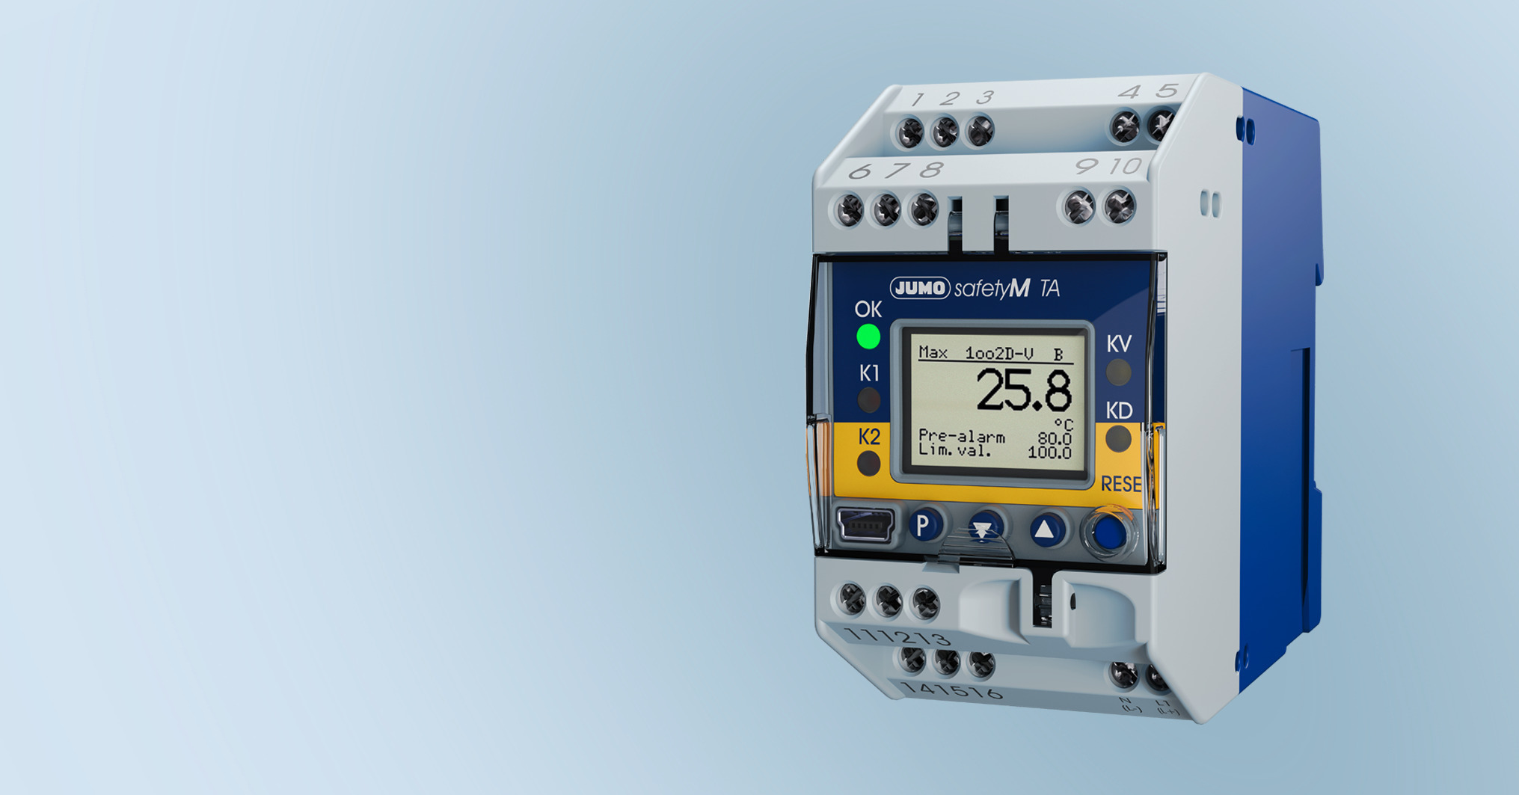

Photo: JUMO
Press release
PI 2533

Page 2 of 2

Image caption: Thanks to its universal input for pressure, flow, temperature, and level, the JUMO safetyM TA can be easily configured to a wide range of process requirements.

The JUMO corporate group, based in Fulda, Germany employs over 2400 people worldwide. It is a leading system and solution provider in the field of industrial sensor and automation technology. JUMO products are used in industries such as "thermoprocess technology", "heating, ventilation, and air conditioning", "food and beverage", "renewable energy", and "water and wastewater". The company posted a turnover of 301 million euro in 2024.

